Project Title: Visualizing and Predicting Heart Diseases with an Interactive Dashboard Team ID: PNT2022TMID03384

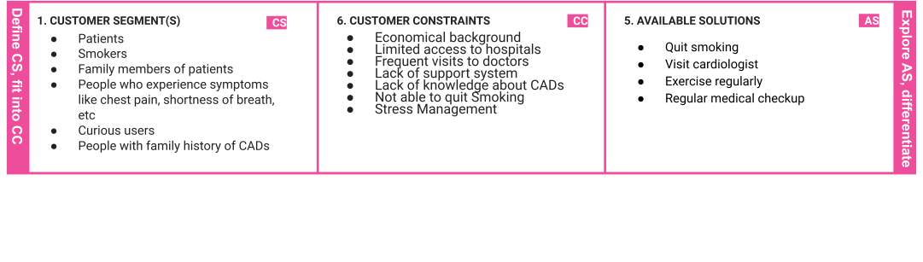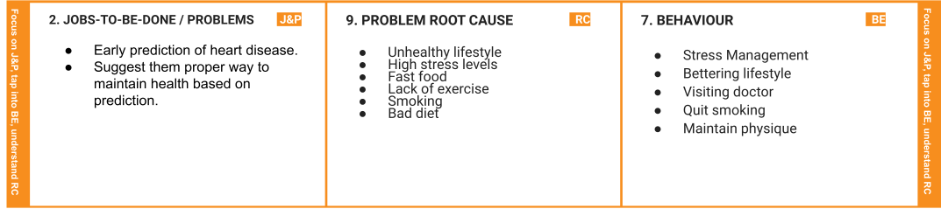

|  |  |  |  |  |  |  |
| --- | --- | --- | --- | --- | --- | --- |
|  | 1. **TRIGGERS**    * Discomfort    * Common symptoms like chest pain,shortness of breath,etc    * emotional stress | **TR** | 1. **YOUR SOLUTION**   **SL**   * + Early prediction of heart diseases.   + Predicting heart disease can help in getting better cures for the same disease.   + Suggest lifestyle changes that are required | 1. **CHANNELS of BEHAVIOUR**    1. **ONLINE**       * Finding possible cures       * Booking online appointment       * Searching health related website    2. **OFFLINE**       * Visit Cardiologist       * Maintaining ﬁtness       * Bettering lifestyle   . | **CH** |  |
| 1. **EMOTIONS: BEFORE / AFTER**   Before:   * + Worried   + Fear   + Anxious After:   + Relieved   + Better control on emotions   + Clarity   + Visit doctor if required | **EM** |